Name: Samarth Mukesh Pawar
Project: Generative AI-Based Ligand Binding Pose Refinement from Physics-Based Priors
Report 1: Understanding of Proteins, Substrate and Molecular Docking

Topics:
- Proteins (Amino Acids)
- Substrate
- Molecular Docking

PROTEINS:
- Proteins transport nutrients, catalyze chemical reactions and are the structural components of living organisms.
- Proteins are made up of 20 set of standard amino acids.

AMINO ACIDS:
- They are mainly composed of carbon, oxygen, nitrogen and hydrogen.
- Each amino acid has three key parts attached to a central (alpha) carbon atom:
  - . An amino group (-NH2)
  - . A carboxyl group (-COOH)
  - . A side chain (R group) - the only part that varies between amino acids and determines their chemical properties.
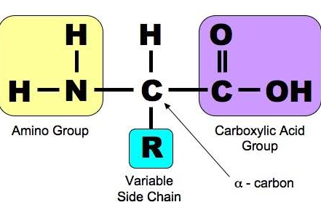
- Amino Acids are classified by their side chain (-R group) structure.
  - Hydrophobic: The side chain that repel water molecules.
  - Hydrophilic: The side chain which favorably interact with water molecules (through hydrogen bonding).
  - Charged: Interact with oppositely charged molecules/amino acids.
PRIMARY STRUCTURE OF PROTEINS:
- The primary structure of proteins is formed due to the linear sequential joining of amino acids as encoded by the DNA.
- The amino acids are joined via peptide bonds.

